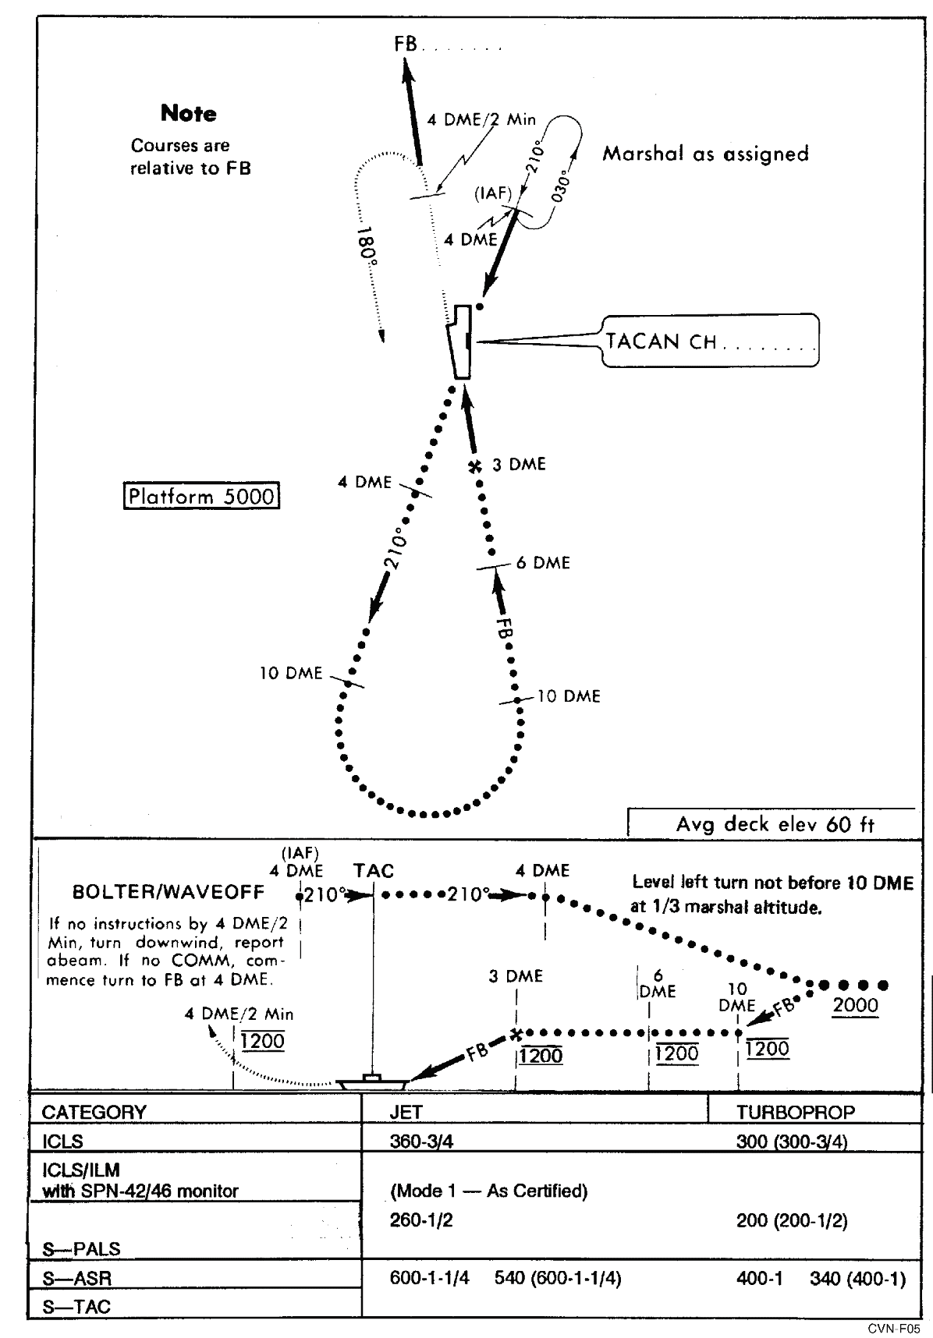

**Approach Chart CV-2 TACAN Overhead (Jet and Turboprop)**